|  |  |
| --- | --- |
| Project Name | Gas leakage Monitoring |
| Team ID | PNT2022TMID42892 |
| Team Members | S.Mownika N.Indhumathi M.Gowri  V.Prithika |

Gas Leakagemonitoring & Alerting system for Industries

Introduction:

**Project overview and purpose:**

**Objective :-**

The design of a sensor-based automatic gas

leakage detector with an alert and control system has been proposed .This is an affordable, less power using, lightweight, portable, safe, user friendly, efficient, multi featured and simple system device for detecting gas. Gas leakage detection will not only provide us with signiﬁcance in the health department but it will also lead to raise our economy, because when gas leaks it not only contaminates the atmosphere, but also wastage of gases will hurt our economy. The need for ensuring safety in workplaces is expected to be the key driving force for the market over the coming year.

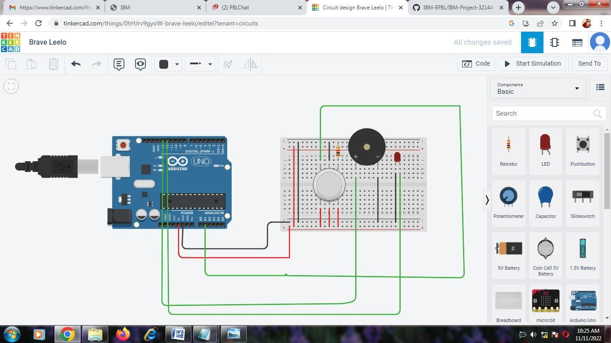

# Literature Survey

Problem Statement Definition:

The presence of hazardous LPG gas leakage in a domestic, work place, also, stored gases container gas which exhibits ideal characteristic is use. For that sake, an alarm unit is used to vibrate an alarm which is buzzer. Buzzer gives an audible sign of the presence of LPG volume. The sensors are widely used to detect essence of propane, iso-butane, LPG and even smoke. The sensor has an advantage to combine a sensitivity response time. If the LPG sensor senses gas leak from work place or home, sensor output goes to active low (logic-0) condition. Arduino UNO is used in the project; low signals are overlooked by the Arduino and gas leakage is been noticed by the Arduino. The Arduino UNO turns on the LCD and buzzer. It even turns on the GSM modem after that, it continues to send messages SMS to mobile number specifically mentioned in the program of the source code for alerting danger to the people.

Existing problem & Reference

|  |  |  |  |  |
| --- | --- | --- | --- | --- |
| Sr. No | Paper Title | Author Name | publication year | Result |
| 1. | Internet of Things (IOT) Based Gas Leakage Monitoring and Alerting  System with MQ-2 Sensor | Rohan Chandra Pandey, Manish Verma, Lumesh  Kumar Sahu | 2017 | Thism paper choice of using a real time gas leakage monitoring and Sensing the output levels of gas has been clearlyobserved bythe help of this system. |
| 2. | Gas Leakage Detection and Smart Alerting and Prediction Using IoT | Asmita Varma, Prabhakar S, Kayalvizhi Jayavel | 2017 | The proposed gas leakage detector is promising in the Field of safety. |

# Ideation & Proposed Solution

Empathy Map Canvas

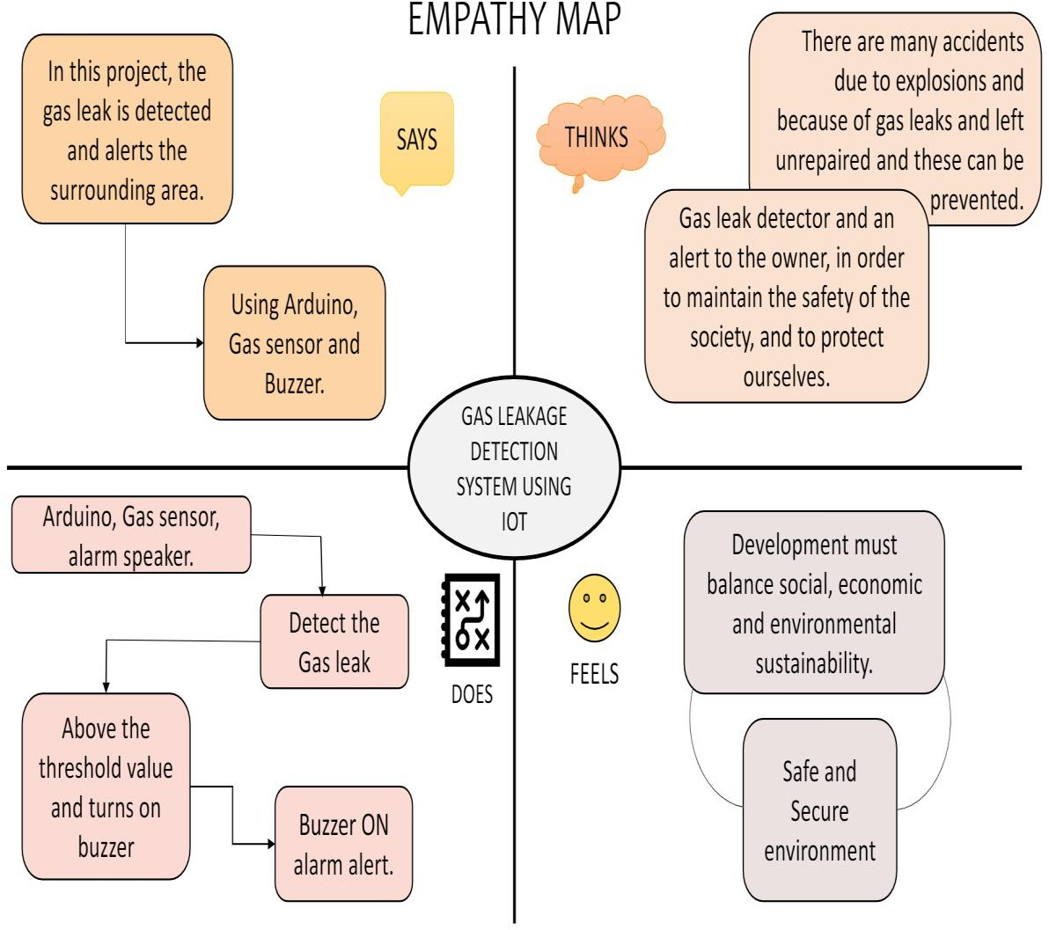

**PROPOSED SOLUTION:**

## PROBLEM STATEMENT.

There have been many incidents like explosions and fires due to LPG gas leakage. Such incidents can cause dangerous effects if the leakage is not detected at an early stage. Arduino and IOT based LPG leakage detection system is a project which will help in determining gas leakage in the surroundings and send data to an IOT module. Internet of Things(IoT) is the networking of things by which physical things can communicate with the help of sensors, electronics, software and connectivity. These systems do not require any human interaction and the same is the case with iot based gas detection system. It does not require human attention.

## IDEA /SOLUTION DESCRIPTION

the Arduino Uno-based LPG detector system project is that it gives remote indications to the user about the LPG leakage with the help of SMS sing. This project has applications in our home. We can also use this gauge in industries, offices, and colleges where the LPG gas cylinder is used in the canteen. This project also has use in hotels and restaurants. To refine this project, we can add a GPS modem to this system. It is used in dangerous Gas detection. It is used in Fire Hazard Prevention. It is also used in Oxygen level Measurement. The sensor has exquisite sensitivity combined with a precipitate response time. The system is highly authentic, tamper-proof, and fixed. in the long run, the preservation cost is very less when compared to the present systems.

## NOVELTY/UNIQUENESS.

Here, we use IOT technology for enhancing the existing safety standards. While making this prototype has been to bring a revolution in the field of safety against the leakage of harmful and toxic gases in environment and hence nullify any major or minor hazard being caused due to them. We have used the IOT technology to make a Gas Leakage Detector for society which having Smart Alerting techniques involving sending text message to the concerned authority and an ability performing data analytics on sensor. This system will be able to detect the gas in environment using the gas sensors. This will prevent form the major harmful problem.

## SOCIAL IMPACT/ CUSTOMER SATISFACTION.

Gas leakage leads to various accident resulting in both material loss and human injuries the risk of explosion firing suffocation are based on their physical properties such as toxicity flammability etc, so to satisfy the customer needs we introduce the gas leakage alerting and monitoring system . This system will not only able to detect the leakage of gas but also alerting through audible alarms. Presence of excess amounts of harmful gases in environment then this system can notify the user. System consists of gas detector sensors, Arduino board, ESP8266 and Cloud server.

## BUSINESS MODEL(FINANCIAL BENEFIT).

Unidentifiable gas leaks give rise to explosions that are harmful to the employees working in the hazardous environment. In the automotive industries like oil and gas, hotels, and places where flammable gases are used in abundance, a gas detection system is a basic requirement for safety. An IoT powered gas detection solution uses gas sensors to identify the presence of toxic gases such as CO2, CO, NOx in the industrial facilities. Especially, in the oil and gas industry where many gaseous products like propane, butane, and hydrogen are manufactured at a greater level. Hence, the chances of gas explosions are higher as these gases are easily combustible in the oxygen-rich environment. Apart from these, toxic gases like hydrogen sulfide (H2S) is produced during refining processes that might harm the workers’ health.

Thus, it becomes a necessity to keep a real-time check on gas production. If these toxic gases are released untreated, their harmful contaminants result in air pollution and acid rains. The Internet of Things is an advanced technology that works on multiple levels creating a smart network of sensor devices, equipment, and assets. These devices help provide valuable data for analysis and allow the industrialists to make better decisions. In a gas monitoring system, the gas detection sensors are installed strategically on different locations for real-time monitoring. These sensors then alert the managers via a centralized platform through live notifications when the gas is detected.

## SCALABILITY OF SOLUTION

It enables threshold-based triggers that alert the concerned managers with visual and sonic alarms. – Accurate data monitoring helps timely actions for a known concentration of air pollution. – Also, multiple deployments across any potential sources can help industries to avoid any industrial incident and protect workplace safety. Scalability offers an efficient, cost-effective solution to achieve reliable condition monitoring of a rapidly increasing number of assets without increasing staff resources to match. Our end to end wireless gas monitoring system uses wireless sensors to detect the presence of toxic gases. The solution can hence be scaled up for flexible functionality and offer great extendibility for multi- purpose usage.

# Requirement Analysis

Functional Requirement & Non Functional Requirement

|  |  |  |
| --- | --- | --- |
| **Business Requirements** | **User Requirements** | **Product Requirements** |
| This system may be used in residences, hotels, industrial buildings, LPG cylinder storage sites, and other locations. This IoT and Arduino-based application's key benefit is its ability to identify leaks and transmit the information to a site. It can be tracked and disasters can be avoided by taking  precautions. | The gas leakage detection system may be upgraded to include smoke and fire detectorsin order to better detect dangerous gases and identify thethe presence of fire and smoke.  Although ensuring worker safety is  critical, adopting the appropriate technology is even more crucial. | Regardless of your career or personal circumstances, gas detection is required.  purpose. In order to participate in IoT application development,you must be aware of the technologiesat work that give rise to such IoT devices as well as the functions they may carry out. |

# Project Design.

Data flow Diagrams

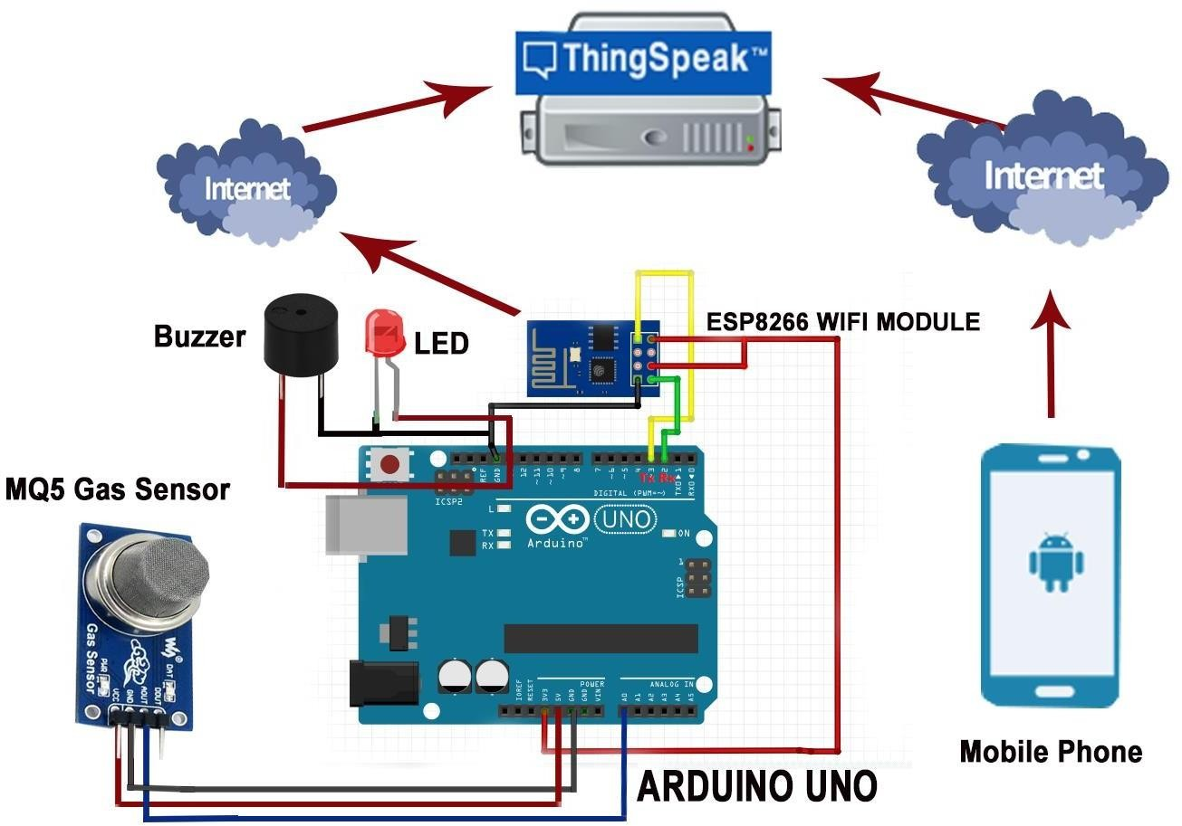

Solution & Technical Architecture

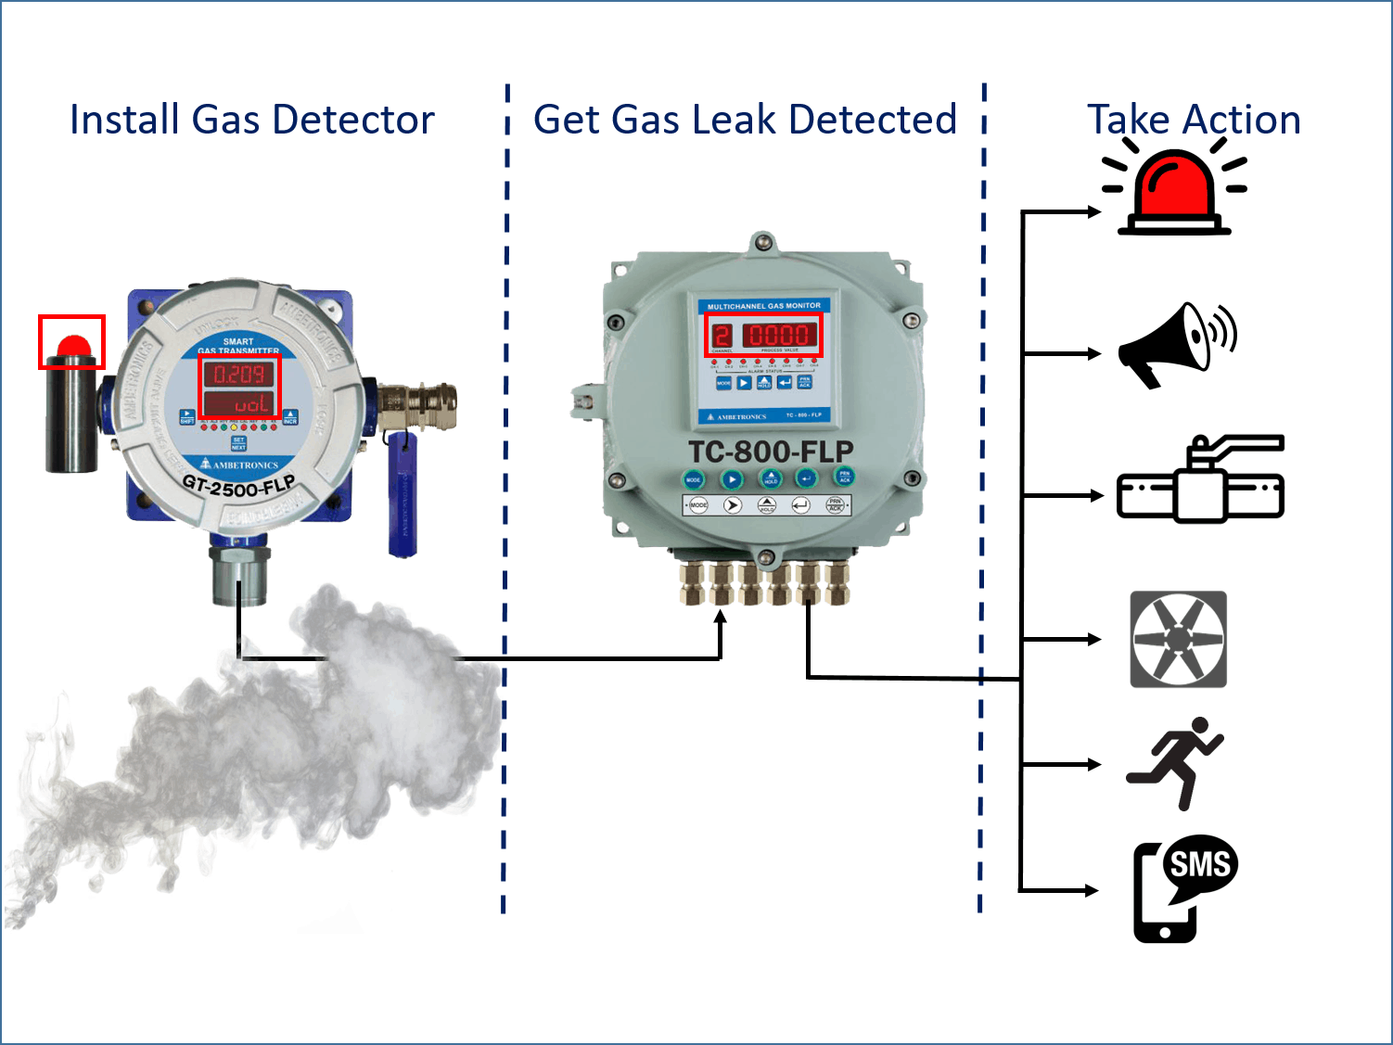

Project Planning & Scheduling

#include <LiquidCrystal.h> LiquidCrystallcd(5,6,8,9,10,11);

int redled = 2; int greenled = 3; int buzzer = 4; int sensor = A0;

int sensorThresh = 400;

void setup()

{

pinMode(redled, OUTPUT); pinMode(greenled,OUTPUT); pinMode(buzzer,OUTPUT); pinMode(sensor,INPUT); Serial.begin(9600);

lcd.begin(16,2);

}

void loop()

{

int analogValue = analogRead(sensor); Serial.print(analogValue); if(analogValue>sensorThresh)

{

digitalWrite(redled,1); digitalWrite(greenled,0);

tone(buzzer,1000,10000); lcd.clear(); lcd.setCursor(0,1); lcd.print("ALERT"); delay(1000);

lcd.clear(); lcd.setCursor(0,1);

lcd.print("EVACUATE"); delay(1000);

}

else

{

digitalWrite(greenled,1); digitalWrite(redled,0); noTone(buzzer); lcd.clear(); lcd.setCursor(0,0); lcd.print("SAFE"); delay(1000); lcd.clear();q lcd.setCursor(0,1); lcd.print("ALL CLEAR"); delay(1000);

}

}

Coding

int gasSensor=A1; int buzzer=13;

int led=12; void setup()

{

pinMode(A1, INPUT); pinMode(buzzer, OUTPUT); pinMode(led, OUTPUT); Serial.begin(9600);

}

void loop()

{

int sensorValue=analogRead(gasSensor); Serial.print("Gas Level:"); Serial.println(sensorValue); delay(1000);

if (sensorValue>250)

{

digitalWrite(buzzer,HIGH); digitalWrite(led,HIGH);

}

else

{

digitalWrite(buzzer,LOW); digitalWrite(led,LOW);

}

# Result:



Advantages:

• Because of the very narrow 0.3 nm line width of the laser emission, there is no interference from other gases.

• Response times are in the order 1 second. This allow for fine resolution/control when making process measurements.

• The intense laser light concentrated at the absorption wavelength enables path lengths up to 1 km to be measured.

• An average measurement is taken over the total path so that a narrow plume of gas has less chance of escaping detection.

• The range of measurement can be up to 4 orders of magnitude, enabling concentrations of 0.1 ppm to 1000 ppm to be measured.

• Because of the internal reference cell, the system is self calibrating.

• There is no ‘poisoning’ or degradation of the instrument with long term exposure to a gas.

• Can easily be conformed to be ‘Intrinsically Safe’.

• Low maintenance and low operating costs.

• Reliable technology.

Disadvantages:

• Only one gas can be measured with each instrument.

• When heavy dust, steam or fog blocks the laser beam, the system will not be able to take measurements.

This is also the case when a person or vehicle blocks the path.

Conclusion:

After this project performance, can conclude that detection of the LPG gas leakage is incredible in the project system. Applicable usefully in the industrial and domestic purpose. In danger situations we are able to save the life by using this system. An alert is indicated by the buzzer and light . A sensor node senses gas like CO2, oxygen, propane. The estimated

ange of transmission and consumption of power is obtained. The simple procedures and Arduino UNO Micro controller area used to buildthe sensor.

Future Scope:

* The said system can be deployed in homes, hotels, factory units, LPG cylinder storage areas, and so on. The main advantage of this IoT and Arduino-based application is that it can determine the leakage and send the data over to a site. It can be monitored, and preventive measures can be taken to avoid any disaster.

* Suppose corrective steps are taken promptly after it is reported over the IoT devices. In that case, that can help save the loss of lives, alleviate any mishaps from happening, and cut down on business expenses.
* The gas leakage detection system can be optimized for detecting toxic gasses along with upgrading them with smoke and fire detectors to identify the presence of smoke and fire. Ensuring worker safety is important but making using of the right technology is even more vital.

Appendix:

Sourcecode:

int gasSensor=A1; int buzzer=13;

int led=12; void setup()

{

pinMode(A1, INPUT); pinMode(buzzer, OUTPUT); pinMode(led, OUTPUT); Serial.begin(9600);

}

void loop()

{

int sensorValue=analogRead(gasSensor); Serial.print("Gas Level:"); Serial.println(sensorValue); delay(1000);

if (sensorValue>250)

{

digitalWrite(buzzer,HIGH); digitalWrite(led,HIGH);

}

else

{

digitalWrite(buzzer,LOW); digitalWrite(led,LOW);

}

GitHub link:

[IBM-EPBL/IBM-Project-32144-1660208264](https://github.com/IBM-EPBL/IBM-Project-32144-1660208264)

Project Demo link:

<https://photos.app.goo.gl/BZYrQA7m8NPoiWFd8>